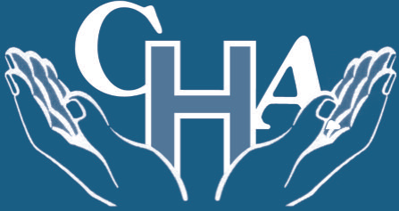

Community Hospitals Association Improving Practice

Innovation and Best Practice Award 2018 Summary
Title:
Bereavement Sleeves
Background:
Following the death of their relative patients were given the leaflets that they needed to give them information of what procedures they needed to follow.
We felt that this information could be presented to them in a more discreet way at such a sensitive emotional time.
Description:
On the ward we make bereavement sleeves with a small gift inside for the relatives that house leaflets that relatives need following a patient’s death.

On the ward we have two palliative care beds within a dedicated suite. Patients can be referred to the suite for time specific respite care, symptom control and end of life care.
When a patient sadly dies we have information leaflets that we give to the bereaved relatives. These leaflets reiterate verbal information that we give them that they may not always fully take in due to the circumstance that they are in.
The palliative care link nurses consisting of Sister Donna Phillips and a former staff nurse Marie Powell (who is now working for the local hospice) developed a sleeve that these leaflets can be placed inside to make it more discreet for the families at this distressing time.
The sleeves are all made by hand personally by the staff. They are all unique and have different decorative emblems on them, but all have the same comforting verse on the front.
A few years ago, we made an addition to the sleeves by adding an envelope containing a card inside which we place a packet of forget me not seeds as a token from the Scotter Ward team to help with memories and enable them, when they feel ready if they wish, to plant the seeds.
Outcome and Impact:
Relatives can take away the information that they need following the death of a loved one in a discreet sleeve and can plant the forget me not seeds should they wish to and have another lasting memory courtesy of the Scotter Ward Team.
The idea is a small gesture, but we believe it can make a difference at such a significant time for the relatives. The sleeve enables the relatives to keep the leaflets safe and not on view until they feel ready to read them and deal with the procedures that follow the death of a loved one.

This idea has been widely shared on our social media sites and as two articles on FAB NHS Stuff. Many wards and hospitals across the country have adopted the idea to use in their areas of which we feel very proud that our idea is helping bereaved family’s nation wide
Supporting Information:
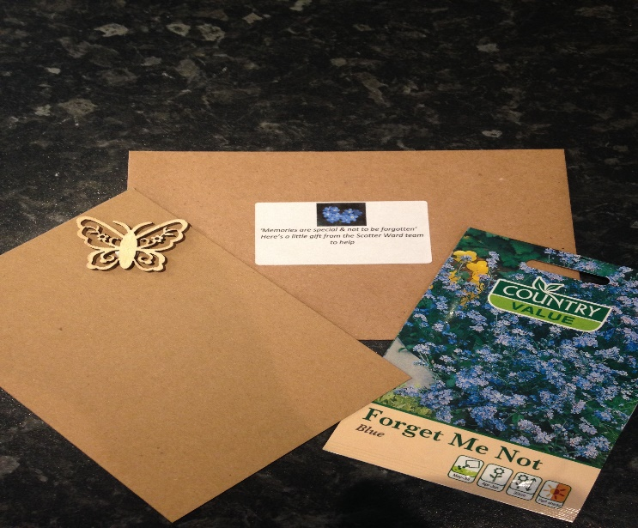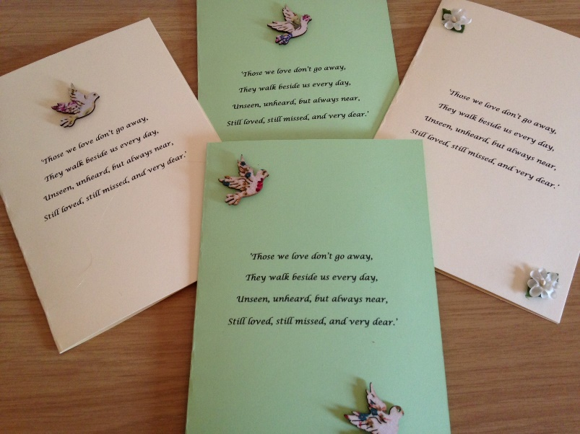
Organisation:
Scotter Ward
John Coupland Hospital
Lincolnshire Community Health Services
Contact details:
Donna Phillips
Clinical Team Lead
01427 816542
Donna.phillips@lincs-chs.nhs.uk
CHA Judges Comments:
This innovation is a highly sensitive and appropriate way of supporting bereaved families. The staff have worked together to make sure that they share information in a sensitively done, in a caring way. We were impressed with the fact that staff created personal sleeves, in their own time and recognised that this extra touch, at this difficult time could help families.

